In the Approach Section before the Experimental Design section

APPROACH
The approach for the proposed studies is based on our prior extensive experience in applying a XXXXX platform for XXX (7; 10-15). Our group pioneered this work and had since significantly advanced the technology (56-60). Below, we summarize our Preliminary Results supporting the proposed Specific Aims.
PRELIMINARY RESULTS (you may not have results supporting all aims)
1. The XXXXX targets XXXXX in breast tumor cells and inhibits their invasion, migration, and proliferation (7). Your published study
To test if XXXX can be inhibited in vitro and in vivo, we designed XXXXX conjugated to XXXX peptide, which targets XXXXX (27-29). The step-by-step synthesis, characterization as well as toxicity, stability and XXXXXXXXXXX. ………….These results support Specific Aim 2 focused on XXXX…….
2. In vitro testing of the XXX in cell systems
……………
3. In vivo testing of the XXX in animal models XXXXXX
……………
EXPERIMENTAL DESIGN
Specific Aim 1………………..

Within Experimental Design before each Specific Aim
APPROACH
EXPERIMENTAL DESIGN
Preliminary Results in support of Aim 1.
……………….
Specific Aim 1………………..

Specific Aim 1.1. …………….

Specific Aim 1.2

Preliminary Results in support of Aim 2.
……………….
Specific Aim 2. ……………..
Specific Aim 2.1……………..

Within Experimental Design within each Specific Aim

APPROACH
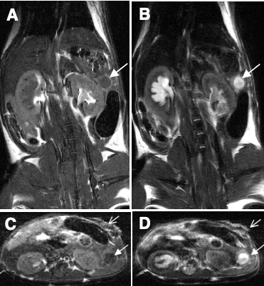
Figure 11. MRI of XXX tumor (closed arrows). Gd- enhanced T1W images (A, coronal and C, transverse) and T2W coronal (B) and transverse (D) images. (54).
EXPERIMENTAL DESIGN
Specific Aim 1………………..

Specific Aim 1.1. …………….

Specific Aim 1.2. Compare treatment efficacy with XXXXX, alone or in combination with XXXX, to anti-mouse XXXX antibody, alone or in combination with XXXX. Monitor delivery to tumors and therapeutic response of XXXX by in vivo MRI.
Treatment groups: Treatment will start once primary tumors are in an exponential phase of growth, as determined by anatomic MRI XXXXXXXXX. For anatomic MRI we will acquire T1 weighted images with and without Gd contrast agent XXXXX. In our previously published studies we already demonstrated XXXXXX (54). Representative images shown in Fig. 11 show significant increase in signal intensity in the tumor region XXXXXX.

